C:\Users\Ashish Kumar Namdeo\Desktop\logo_small_word.tif

**STUDENTS’ GYMKHANA ELECTIONS**

**Year 2018-19**

Indian Institute of Technology, Guwahati

**Nomination Form**

File Ref: IITG/SAC/GYM18/Elections/Nominations/

Post contesting for: Girls Senator

**Candidate details:**

|  |  |
| --- | --- |
| Name: Parul Bansal | |
| Roll No.: 160107038 | Dept. /Branch: Chemical Engineering |
| CPI: 8.31  Backlogs: 0 | Semester: 4  Active Backlogs (if any): 0 |
| Email Id: parulbansal98@iitg.ernet.in | Contact No.: 9954349714 |
| Hostel: Dhansiri | Room No.: Af-10 |

Signature with date: 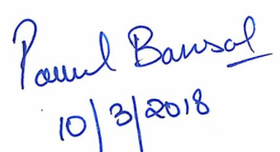

**Proposed by:**

|  |  |
| --- | --- |
| Name: Shruti Sharma | |
| Roll No.: 160107058 | Dept. /Branch: Chemical Engineering |
| CPI: 7.79 | Semester: 4 |
| Email Id: shrutisharma@iitg.ernet.in | Contact No.: 8486778987 |
| Hostel: Dhansiri | Room No.: AF-08 |

Signature with date: 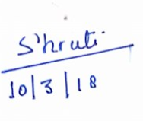

**Seconded by:**

|  |  |
| --- | --- |
| Name: Srushti Dakhare | |
| Roll No.: 160104017 | Dept. /Branch: Civil Engineering |
| CPI: 7.03 | Semester: 4 |
| Email Id: srushti.dakhare@iitg.ernet.in | Contact No.: 9957992159 |
| Hostel: Dhansiri | Room No.: AF08 |

Signature with date: 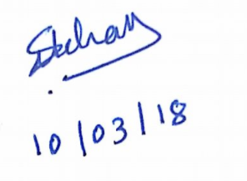

**1. Feminine Sanitation**

**Domain :**  Student’sWelfare Board

To enable girls to focus on growing as individuals and furthering their roles in contributing to society, they need to be able to worry less about their own health. And sanitation being a very important aspect, it needs to be addressed with greater caution and detail.

**Proposal:** To improve the sanitation for girls.

**Solution and plan of action :** Automation vending machines for Sanitary Napkins & Tampons, installed in the ladies’ washrooms in the Lecture halls and Academic Cores 1 & 4.

**2.Course Feedback**

**Domain :** Academic section

Feedback taken at the end of the course – as is the case presently – is not of much benefit for the students writing that feedback.

**Proposal:** Improvement of course feed-back structure.

**Solution and plan of action :** Anonymous feedback through a week long, online portal - at an earlier stage, i.e. , after the first 6 classes of the course. It shall help bridge the gap between he professor and the students.

.

C:\Users\Ashish Kumar Namdeo\Desktop\logo_small_word.tif

**STUDENTS’ GYMKHANA ELECTIONS**

**Year 2018-19**

Indian Institute of Technology, Guwahati

File Ref: IITG/SAC/GYM18/Elections/Agenda/

Post contesting for: Girls Senator

|  |
| --- |
| Name: Parul Bansal |
| Nick Name: Parul |
| Tagline (Punch line): WHAT WE FEAR OF DOING MOST IS USUALLY WHAT WE MOST NEED TO DO. |

**Agendas:**

**1.Feminine Sanitation**

**Domain :**  Student’sWelfare Board

To enable girls to focus on growing as individuals and furthering their roles in contributing to society, they need to be able to worry less about their own health. As periods and sanitation being a very important aspect, it needs to be addressed with greater caution and detail.

**Proposal:** To improve the sanitation for girls.

**Solution and plan of action :** Automation vending machines for Sanitary Napkins & Tampons, installed in the ladies’ washrooms in the Lecture halls Library, and Academic Cores 1 & 4.

**2.Course Feedback**

**Domain :** Academic section

Feedback taken at the end of the course – as is the case presently – is not of much benefit for the students writing that feedback.

**Proposal:** Improvement of course feed-back structure.

**Solution and plan of action :** Anonymous feedback through a week long, online portal - at an earlier stage, i.e. , after the first 8-10 classes of the course. It shall help bridge the gap between he professor and the students. The type of feedback will be completely different from existing feedback and will be mainly focused on quality of teaching.

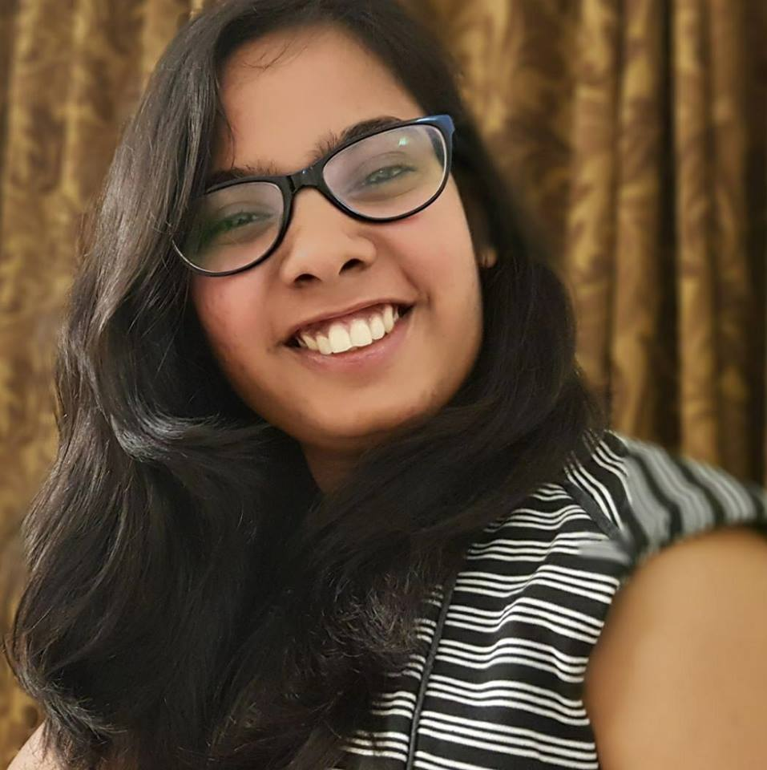

Photograph

**Agendas and Declaration Form**

**3.Library**

**Domain :** Library Administration

During exam season, late night study at the Central Library is accompanied by discomfort that arises from hunger and sleep. Unavailability of food or hot beverages nearby adds to the pre-existing stress. Going back to the hostels for food is a distraction and consumes a lot of time of the students .

**Proposal:** Provision of basic needs in the library during the exams.

**Solution and plan of action:** A provision of 24x7 Canteen during exams, near the library and stationery-cum-photocopy shop to help with books, resources and notes. during mid-semester and end semester examinations. Alongside or instead, depending on feasibility – Automatic Tea and Coffee Vending Machines in common areas during regular days.

Further a online portal for re-issuing of books will be made to make it easier for students to re-issue the books.

**4. Aerobics and Gymnastics**

**Domain :** Cultural Board and sports Board.

Amid activities such as Yoga, Aerobics and Cardio, what seems amiss is a place for those interested to indulge into the above mentioned.

**Proposal:** To introduce fitness workshops

**Solution and plan of action :** Starting off with a couple workshops every semester, with the help of Cadence and other interested stakeholders, interest unto Aerobics and Gymnastics shall be brought out t public knowledge. Assessing thereafter, the viability of an investment of time, effort and otherwise into the required infrastructure and amenities for a dedicated Gymnastics club, the same may be formed and set up.

**5.Fellowship Portal**

**Domain :** Center for Carrier Development

There is lack of organized information and clarity regarding available opportunites – misorganized mails and notices flood the webmail randomly

**Proposal:** Online portal for the internships and fellowships.

**Solution and Plan of Action:** An Online Information Centre , managed by the Center for Career Development and maintained. It shall have periodically organized information regarding fellowships, internships and similar opportunities; accompanied by the approaching deadlines. Apart from clarity, this shall induce a greater sense of transparency concerning the availability of opportunities. The portal may have links to further reference.

**6. Undergraduate Research**

**Domain :** Academic section

Majority of the research undertaken in the institute is by the post graduate and PhD students. In order to instill an interest towards the same, among the Undergraduate diaspora, a greater set of incentives are required, over the existing ones that pertain to skill and resume development

**Proposal:** Increase undergraduate research.

**Solution and plan of action :** Formation of a committee (or extension of the mandate of a pre-existing one) to evaluate entries and submissions made specifically by Undergraduates, eventually awarding the deserving candidates. This would not only provide for a much needed incentive, but also would act as an apex body to regulate and process requests and subsequent approvals concerning projects.

**Declaration by the candidate:**

I hereby declare that the above information is to the best of my knowledge. I do not have any disciplinary probation by the Institute and will abide by the rules and regulations laid for Gymkhana Election. I do not have any active backlogs to be cleared.

I know that any false information in this nomination form will lead to cancellation of my nomination and disciplinary action.



Signature of candidate with date: Signature of CEO

1. Former organizer at techexpo, techniche IIT Guwahati.
2. Mentor at Disha.(non – profit student organization run by the students of IIT Guwahati)
3. PH102 Mentor at Peer assisted learning.

**Experiences (Credentials if any):**